**AI BASED APTITUDE SOLVER**

Ajay Biswas

Department of Computer Science and Engineering, University Institute of Technology The University of Burdwan, Burdwan, India. ajaybiswas22@gmail.com

**ABSTRACT**

An aptitude is a component of a competence to do a certain kind of work at certain level. General Aptitude problems are faced by students and jobseekers worldwide to enter into the professional world. Though we formulas to calculate these problems but require certain level of IQ to analyse and solve these problems. With this software computers will be able to solve Aptitude problems using natural language processing. This software can be useful for the preparation for competitive exams and in universities.

Keywords: Natural language processing, Aptitude, Reasoning

**INTRODUCTION**

A computer is a device that can be instructed to carry out sequences of arithmetic or logical operations automatically via computer programming. Modern computers have the ability to follow generalized sets of operations, called programs*.* These programs enable computers to perform an extremely wide range of tasks. Though computers have the ability to solve numerical problems at incredible speed, yet they lack intelligence. Computers cannot truly reason themselves, instead they are programmed in such a way that they resemble human thinking. This can be achieved by use of artificial intelligence.

Artificial intelligence (AI), sometimes called machine intelligence, is intelligence demonstrated by machines, in contrast to the natural intelligence displayed by humans and other animals. In computer science AI research is defined as the study of "intelligent agents": any device that perceives its environment and takes actions that maximize its chance of successfully achieving its goals [1]. Colloquially, the term "artificial intelligence" is applied when a machine mimics "cognitive" functions that humans associate with other human minds, such as "learning" and "problem solving” [2].

A general aptitude question consists of different variables and values hidden in the natural language, and has a goal statement. In order to reach to the goal, the software has to understand the natural language used in proposed statement and identify the problem type.

**PROPOSED WORK**

The execution of the program consists of three steps:

* Problem Identification

The user will input the problem in the provided text box along with multiple choices. At first the software looks for keywords in the problem. If it matches with the entries in the database, next database is loaded where similar type of problem may exist. The task of the program is not only to identify the problem but also to ignore unnecessary information provided with the problem.

* Formulation of the problem

Once the problem is identified, the program searches for variables involved. When all of the variables are identified, they are placed in a temporary file along with their values if provided in the problem statement. The formula provided in the database is modified accordingly with new values and is copied to a temporary file.

* Problem Solving

The formula is processed and the required output is generated. The best suitable answer among the choices is selected. It may happen that choices may not be in the simplest form. The software will simplify the choices to its simplest form i.e. decimal form and compare it with the answer. The user may change efficiency of the program according to their requirement.

**RESULTS**

The software is able to provide with consistent results as long as the problems are matching with the entries in the database.

Screenshots:

Python 3.7, GUI Kivy (framework)

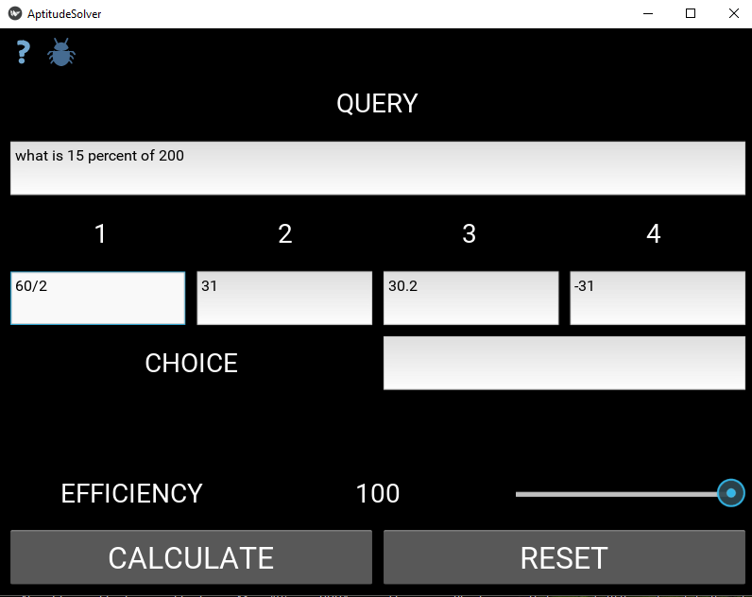

Image 1

Image 2

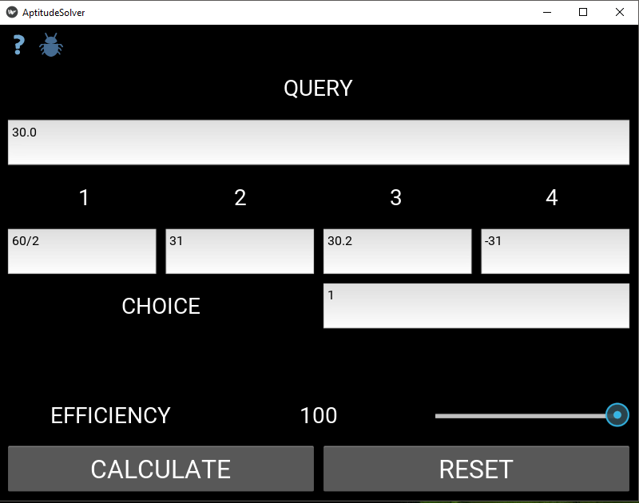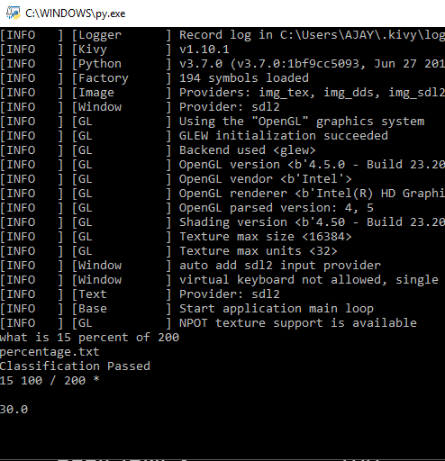

Image 3

The following table shows the accuracy of the software with different problem types.

|  |  |
| --- | --- |
| **Problems** | **Accuracy %** |
| Constants | 99.99 |
| Arithmetic | 99.99 |
| Digits | 100.00 |
| Interests | 99.99 |
| Series | 99.99 |
| Area and Volume | 99.99 |

**CONCLUSION**

This paper presented the working of the AI based aptitude solver. With the advancement of Artificial Intelligence, these kinds of software will be capable of solving problems that was once solvable by humans only. With increase in the size of the database, the software will be able to solve thousands of different types of problems which may take hundreds of years to master by a human being.

**REFERENCES**

[1] Poole, Mackworth& Goebel 1998, [p. 1](http://people.cs.ubc.ca/~poole/ci/ch1.pdf), which provides the version that is used in this article. Note that they use the term "computational intelligence" as a synonym for artificial intelligence.

[2] Russell &Norvig (2003) (who prefer the term "rational agent") and write "The whole-agent view is now widely accepted in the field" (Russell &Norvig 2003, p. 55).